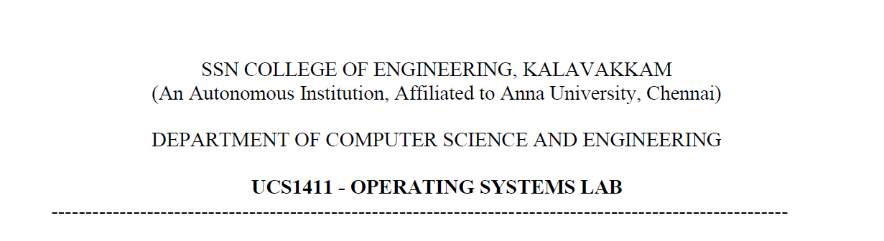

UCS1412 – DBMS Lab

Assignment – 1

Name: Jayannthan P T

Dept: CSE ‘A’

Roll No.: 205001049

**Title:** DDL for Mail Order Database

**Schema Diagram:**

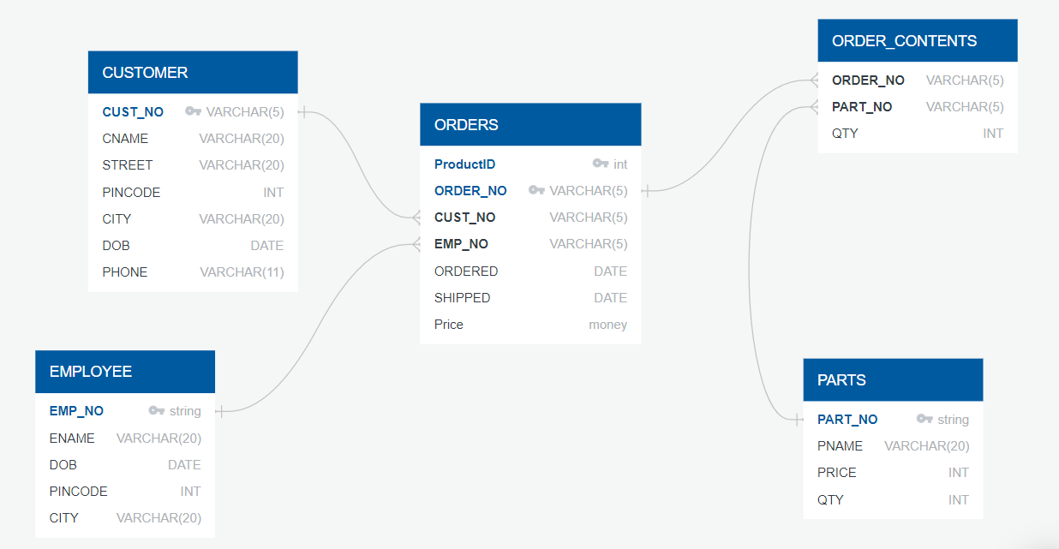

**Observation Index Correction:**

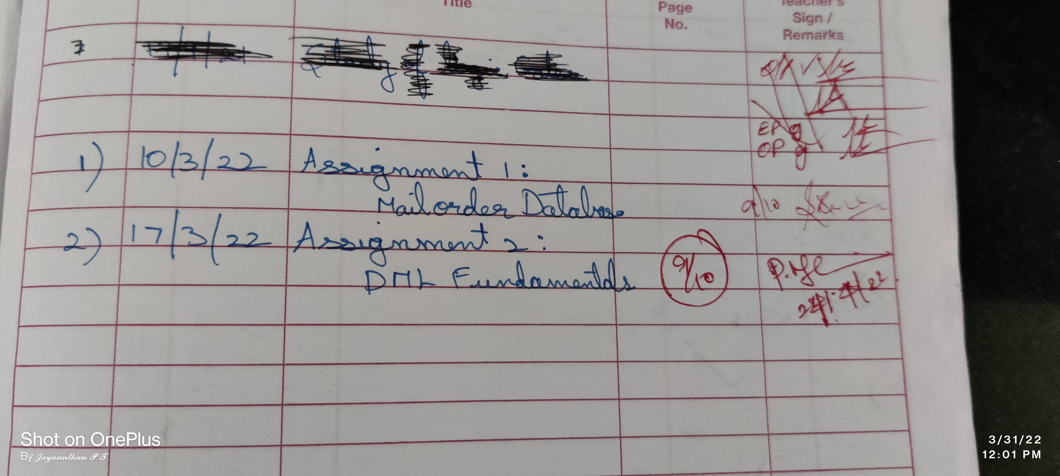

**Spool File Output:**

SQL> REM ***DROPPING TABLES***

SQL>

SQL> DROP TABLE ORDER_CONTENTS;

Table dropped.

SQL> DROP TABLE ORDERS;

Table dropped.

SQL> DROP TABLE PARTS;

Table dropped.

SQL> DROP TABLE CUSTOMER;

Table dropped.

SQL> DROP TABLE EMPLOYEE;

Table dropped.

SQL>

SQL>

SQL> REM ***CREATING TABLE EMPLOYEE***

SQL>

SQL> CREATE TABLE EMPLOYEE(

  2  EMP_NO VARCHAR(5) **CONSTRAINT** E_PRIMEKEY PRIMARY KEY,

  3  ENAME VARCHAR(20),

  4  DOB DATE,

  5  PINCODE INT,

  6  CITY VARCHAR(20),

  7  **CONSTRAINT** ESTART_LETTER **CHECK**(EMP_NO LIKE 'E%')

  8  );

Table created.

SQL> DESC EMPLOYEE;

 Name                                      Null?    Type

*----------------------------------------- -------- ----------------------------*

 EMP_NO                                    NOT NULL **VARCHAR2**(5)

 ENAME                                              **VARCHAR2**(20)

 DOB                                                DATE

 PINCODE                                            **NUMBER**(38)

 CITY                                               **VARCHAR2**(20)

SQL>

SQL> REM ***INSERTING VALUES INTO EMPLOYEE***

SQL>

SQL> INSERT INTO EMPLOYEE VALUES

  2  ('E01','Tony','05-DEC-1992',601101,'Chennai');

1 row created.

SQL> INSERT INTO EMPLOYEE VALUES

  2  ('E02','Steve','23-MAR-1989',601050,'Madurai');

1 row created.

SQL> INSERT INTO EMPLOYEE VALUES

  2  ('E03','Peter','17-JUN-1995',601302,'Trichy');

1 row created.

SQL>

SQL> INSERT INTO EMPLOYEE VALUES

  2  ('E04','Chris','07-JAN-1985',601023,'Kovai');

1 row created.

SQL>

SQL>

SQL> REM \*\*\***check** **constraint** ESTART_LETTER***

SQL> INSERT INTO Employee VALUES ('03','Roshan','29/MAR/2022',600006,'trichy');

INSERT INTO Employee VALUES ('03','Roshan','29/MAR/2022',600006,'trichy')

*

ERROR at **line** 1:

ORA-02290: **check** **constraint** (SYSTEM.ESTART_LETTER) violated

SQL>

SQL>

SQL> REM ***CREATING TABLE CUSTOMER***

SQL>

SQL> CREATE TABLE CUSTOMER(

  2  CUST_NO VARCHAR(5) **CONSTRAINT** C_PRIMEKEY PRIMARY KEY,

  3  CNAME VARCHAR(20),

  4  STREET VARCHAR(20),

  5  PINCODE INT,

  6  CITY VARCHAR(20),

  7  DOB DATE,

  8  PHONE VARCHAR(11) **CONSTRAINT** PHONE_UNIQUE UNIQUE,

  9  **CONSTRAINT** CSTART_LETTER **CHECK**(CUST_NO LIKE 'C%'));

Table created.

SQL> DESC CUSTOMER;

 Name                                      Null?    Type

*----------------------------------------- -------- ----------------------------*

 CUST_NO                                   NOT NULL **VARCHAR2**(5)

 CNAME                                              **VARCHAR2**(20)

 STREET                                             **VARCHAR2**(20)

 PINCODE                                            **NUMBER**(38)

 CITY                                               **VARCHAR2**(20)

 DOB                                                DATE

 PHONE                                              **VARCHAR2**(11)

SQL>

SQL> REM ***INSERTING VALUES INTO CUSTOMER***

SQL>

SQL> INSERT INTO CUSTOMER VALUES

  2  ('C01','Sam','Street1',501101,'Delhi','20-Jul-1999',9673125647);

1 row created.

SQL> INSERT INTO CUSTOMER VALUES

  2  ('C02','Shyam','Street2',501060,'Mumbai','19-Oct-1979',9670005647);

1 row created.

SQL> INSERT INTO CUSTOMER VALUES

  2  ('C03','Stark','Street3',501101,'Kolkata','20-Jul-1999',9848949218);

1 row created.

SQL> INSERT INTO CUSTOMER VALUES

  2  ('C04','Gwen','Street4',501101,'Hyderabad','20-Jul-1999',9676489841);

1 row created.

SQL>

SQL>

SQL> REM \*\*\***check** **constraint** C_PRIMEKEY***

SQL> INSERT INTO CUSTOMER VALUES ('C03','Te','Street',620265,'Madurai','30/JUL/2022',9998865646);

INSERT INTO CUSTOMER VALUES ('C03','Te','Street',620265,'Madurai','30/JUL/2022',9998865646)

*

ERROR at **line** 1:

ORA-00001: unique **constraint** (SYSTEM.C_PRIMEKEY) violated

SQL> REM \*\*\***check** **constraint** CSTART_LETTER***

SQL> INSERT INTO CUSTOMER VALUES ('04','Tem','Street',620275,'pondicherry','30/JUL/2022',999866546);

INSERT INTO CUSTOMER VALUES ('04','Tem','Street',620275,'pondicherry','30/JUL/2022',999866546)

*

ERROR at **line** 1:

ORA-02290: **check** **constraint** (SYSTEM.CSTART_LETTER) violated

SQL>

SQL>

SQL>

SQL> REM ***CREATING TABLE PARTS***

SQL>

SQL> CREATE TABLE PARTS(

  2  PART_NO VARCHAR(5) **CONSTRAINT** P_PRIMEKEY PRIMARY KEY,

  3  PNAME VARCHAR(20),

  4  PRICE INT **CONSTRAINT** PRICENOTNULL NOT NULL,

  5  QTY INT ,

  6  **CONSTRAINT** QTY_MORE **CHECK**(QTY > 0),

  7  **CONSTRAINT** PSTART_LETTER **CHECK**(PART_NO LIKE 'P%'));

Table created.

SQL> DESC PARTS;

 Name                                      Null?    Type

*----------------------------------------- -------- ----------------------------*

 PART_NO                                   NOT NULL **VARCHAR2**(5)

 PNAME                                              **VARCHAR2**(20)

 PRICE                                     NOT NULL **NUMBER**(38)

 QTY                                                **NUMBER**(38)

SQL>

SQL>

SQL> REM ***INSERTING VALUES INTO PARTS***

SQL>

SQL> INSERT INTO PARTS VALUES

  2  ('P01','Screw',70,1000);

1 row created.

SQL> INSERT INTO PARTS VALUES

  2  ('P02','Pipe',50,1500);

1 row created.

SQL> INSERT INTO PARTS VALUES

  2  ('P03','Wire',10,1200);

1 row created.

SQL> INSERT INTO PARTS VALUES

  2  ('P04','Wood',90,1100);

1 row created.

SQL>

SQL>

SQL> REM \*\*\***check** **constraint** PSTART_LETTER***

SQL> INSERT INTO PARTS VALUES ('01', 'ABD', 2500, 25);

INSERT INTO PARTS VALUES ('01', 'ABD', 2500, 25)

*

ERROR at **line** 1:

ORA-02290: **check** **constraint** (SYSTEM.PSTART_LETTER) violated

SQL> REM \*\*\***check** **constraint** P_PRIMEKEY***

SQL> INSERT INTO PARTS VALUES ('P04', 'ABD', 2500, 25);

INSERT INTO PARTS VALUES ('P04', 'ABD', 2500, 25)

*

ERROR at **line** 1:

ORA-00001: unique **constraint** (SYSTEM.P_PRIMEKEY) violated

SQL>

SQL>

SQL> REM ***CREATING TABLE ORDERS***

SQL>

SQL> CREATE TABLE ORDERS(

  2  ORDER_NO VARCHAR(5) **CONSTRAINT** O_PRIMEKEY PRIMARY KEY,

  3  CUST_NO VARCHAR(5),

  4  EMP_NO VARCHAR(5),

  5  ORDERED DATE,

  6  SHIPPED DATE,

  7  **CONSTRAINT** DATE_CHECK **CHECK**(SHIPPED > ORDERED),

  8  **CONSTRAINT** OSTART_LETTER **CHECK**(ORDER_NO LIKE 'O%'),

  9  **CONSTRAINT** FORKEYEMP **FOREIGN KEY**(EMP_NO) **REFERENCES** EMPLOYEE(EMP_NO),

 10  **CONSTRAINT** FORKEYCUS **FOREIGN KEY**(CUST_NO) **REFERENCES** CUSTOMER(CUST_NO));

Table created.

SQL> DESC ORDERS;

 Name                                      Null?    Type

*----------------------------------------- -------- ----------------------------*

 ORDER_NO                                  NOT NULL **VARCHAR2**(5)

 CUST_NO                                            **VARCHAR2**(5)

 EMP_NO                                             **VARCHAR2**(5)

 ORDERED                                            DATE

 SHIPPED                                            DATE

SQL>

SQL>

SQL> REM ***INSERTING VALUES INTO ORDERS***

SQL>

SQL> INSERT INTO ORDERS VALUES

  2  ('O01','C01','E02','26-Jan-2022','3-Feb-2022');

1 row created.

SQL> INSERT INTO ORDERS VALUES

  2  ('O02','C03','E01','29-Jan-2022','8-Feb-2022');

1 row created.

SQL> INSERT INTO ORDERS VALUES

  2  ('O03','C02','E04','8-Feb-2022','19-Feb-2022');

1 row created.

SQL> INSERT INTO ORDERS VALUES

  2  ('O04','C04','E03','13-Jan-2022','24-Jan-2022');

1 row created.

SQL>

SQL>

SQL> REM \*\*\***check** **constraint** O_PRIMEKEY***

SQL> INSERT INTO Orders VALUES('O03', 'C02', 'E03', '12/JAN/2022', '24/JAN/2022');

INSERT INTO Orders VALUES('O03', 'C02', 'E03', '12/JAN/2022', '24/JAN/2022')

*

ERROR at **line** 1:

ORA-00001: unique **constraint** (SYSTEM.O_PRIMEKEY) violated

SQL> REM \*\*\***check** **constraint** DATE_CHECK***

SQL> INSERT INTO Orders VALUES('O04','C04','E03','12/JAN/2022', '10/JAN/2022');

INSERT INTO Orders VALUES('O04','C04','E03','12/JAN/2022', '10/JAN/2022')

*

ERROR at **line** 1:

ORA-02290: **check** **constraint** (SYSTEM.DATE_CHECK) violated

SQL> REM \*\*\***check** **constraint** FOREIGN KEYS***

SQL> INSERT INTO ORDERS VALUES ('O05','C00','E03','13-Jan-2022','24-Jan-2022');

INSERT INTO ORDERS VALUES ('O05','C00','E03','13-Jan-2022','24-Jan-2022')

*

ERROR at **line** 1:

ORA-02291: integrity **constraint** (SYSTEM.FORKEYCUS) violated - parent key not

found

SQL> INSERT INTO ORDERS VALUES ('O05','C01','E00','13-Jan-2022','24-Jan-2022');

INSERT INTO ORDERS VALUES ('O05','C01','E00','13-Jan-2022','24-Jan-2022')

*

ERROR at **line** 1:

ORA-02291: integrity **constraint** (SYSTEM.FORKEYEMP) violated - parent key not

found

SQL>

SQL> REM ***CREATING TABLE ORDER_CONTENTS***

SQL>

SQL> CREATE TABLE ORDER_CONTENTS(

  2  ORDER_NO VARCHAR(5),

  3  PART_NO VARCHAR(5),

  4  QTY INT,

  5  **CONSTRAINT** FORKEYORD **FOREIGN KEY**(ORDER_NO) **REFERENCES** ORDERS(ORDER_NO),

  6  **CONSTRAINT** FORKEYPART **FOREIGN KEY**(PART_NO) **REFERENCES** PARTS(PART_NO),

  7  **CONSTRAINT** ORDERCONTENTSPRIME PRIMARY KEY(ORDER_NO ,PART_NO));

Table created.

SQL> DESC ORDER_CONTENTS;

 Name                                      Null?    Type

*----------------------------------------- -------- ----------------------------*

 ORDER_NO                                  NOT NULL **VARCHAR2**(5)

 PART_NO                                   NOT NULL **VARCHAR2**(5)

 QTY                                                **NUMBER**(38)

SQL>

SQL> REM ***INSERTING VALUES INTO ORDER_CONTENTS***

SQL>

SQL> INSERT INTO ORDER_CONTENTS VALUES

  2  ('O01','P02', 50);

1 row created.

SQL> INSERT INTO ORDER_CONTENTS VALUES

  2  ('O03','P01', 45);

1 row created.

SQL> INSERT INTO ORDER_CONTENTS VALUES

  2  ('O02','P04', 55);

1 row created.

SQL> INSERT INTO ORDER_CONTENTS VALUES

  2  ('O01','P03', 78);

1 row created.

SQL> INSERT INTO ORDER_CONTENTS VALUES

  2  ('O04','P02', 25);

1 row created.

SQL>

SQL> REM \*\*\***check** **constraint** FOREIGN KEYS***

SQL> INSERT INTO ORDER_CONTENTS VALUES('O03', 'P001',4);

INSERT INTO ORDER_CONTENTS VALUES('O03', 'P001',4)

*

ERROR at **line** 1:

ORA-02291: integrity **constraint** (SYSTEM.FORKEYPART) violated - parent key not

found

SQL> INSERT INTO ORDER_CONTENTS VALUES('O00', 'P04',4);

INSERT INTO ORDER_CONTENTS VALUES('O00', 'P04',4)

*

ERROR at **line** 1:

ORA-02291: integrity **constraint** (SYSTEM.FORKEYORD) violated - parent key not

found

SQL>

SQL>

SQL> REM ***ADDING REORDER_LEVEL IN PARTS***

SQL>

SQL> ALTER TABLE PARTS

  2  ADD REORDER_LEVEL INT;

Table altered.

SQL>

SQL>

SQL> REM ***ADDING HIRE_DATE IN EMPLOYEE***

SQL>

SQL> ALTER TABLE EMPLOYEE

  2  ADD HIRE_DATE DATE;

Table altered.

SQL>

SQL>

SQL> REM ***MODIFYING SIZE OF ENAME IN CUSTOMER***

SQL>

SQL> ALTER TABLE CUSTOMER

  2  MODIFY (CNAME  VARCHAR(25));

Table altered.

SQL>

SQL>

SQL> REM ***DELETING DOB IN CUSTOMER***

SQL>

SQL> ALTER TABLE CUSTOMER

  2  DROP COLUMN DOB;

Table altered.

SQL>

SQL>

SQL> REM ***MODIFYING SHIPPED NOT NULL IN ORDERS***

SQL>

SQL> ALTER TABLE ORDERS

  2  MODIFY (SHIPPED DATE **CONSTRAINT** RECIEVENOTNULL NOT NULL);

Table altered.

SQL>

SQL>

SQL>

SQL>

SQL> REM ***CASCADING***

SQL>

SQL> ALTER TABLE ORDER_CONTENTS

  2  DROP **CONSTRAINT** FORKEYORD;

Table altered.

SQL>

SQL>

SQL> ALTER TABLE ORDER_CONTENTS

  2  ADD **CONSTRAINT** FORKEYORD **FOREIGN KEY**(ORDER_NO) **REFERENCES** ORDERS(ORDER_NO) **ON DELETE CASCADE**;

Table altered.

SQL>

SQL>

SQL>

SQL> REM ***VIEW TABLES***

SQL>

SQL> select * from employee;

EMP_N ENAME                DOB          PINCODE CITY                 HIRE_DATE

*----- -------------------- --------- ---------- -------------------- ---------*

E01   Tony                 05-DEC-92     601101 Chennai

E02   Steve                23-MAR-89     601050 Madurai

E03   Peter                17-JUN-95     601302 Trichy

E04   Chris                07-JAN-85     601023 Kovai

SQL>

SQL> select * from customer;

CUST_ CNAME                     STREET                  PINCODE

*----- ------------------------- -------------------- ----------*

CITY                 PHONE

*-------------------- -----------*

C01   Sam                       Street1                  501101

Delhi                9673125647

C02   Shyam                     Street2                  501060

Mumbai               9670005647

C03   Stark                     Street3                  501101

Kolkata              9848949218

CUST_ CNAME                     STREET                  PINCODE

*----- ------------------------- -------------------- ----------*

CITY                 PHONE

*-------------------- -----------*

C04   Gwen                      Street4                  501101

Hyderabad            9676489841

SQL>

SQL> select * from parts;

PART_ PNAME                     PRICE        QTY REORDER_LEVEL

*----- -------------------- ---------- ---------- -------------*

P01   Screw                        70       1000

P02   Pipe                         50       1500

P03   Wire                         10       1200

P04   Wood                         90       1100

SQL> select * from orders;

ORDER CUST_ EMP_N ORDERED   SHIPPED

*----- ----- ----- --------- ---------*

O01   C01   E02   26-JAN-22 03-FEB-22

O02   C03   E01   29-JAN-22 08-FEB-22

O03   C02   E04   08-FEB-22 19-FEB-22

O04   C04   E03   13-JAN-22 24-JAN-22

SQL>

SQL> select * from order_contents;

ORDER PART_        QTY

*----- ----- ----------*

O01   P02           50

O03   P01           45

O02   P04           55

O01   P03           78

O04   P02           25

SQL>

SQL>

SQL>

SQL> REM ***CHECKING **ON DELETE CASCADE**\*\*\*

SQL> DELETE FROM ORDERS WHERE ORDER_NO='O01';

1 row deleted.

SQL>

SQL>

SQL> select * from orders;

ORDER CUST_ EMP_N ORDERED   SHIPPED

*----- ----- ----- --------- ---------*

O02   C03   E01   29-JAN-22 08-FEB-22

O03   C02   E04   08-FEB-22 19-FEB-22

O04   C04   E03   13-JAN-22 24-JAN-22

SQL> select * from order_contents;

ORDER PART_        QTY

*----- ----- ----------*

O03   P01           45

O02   P04           55

O04   P02           25

SQL> spool off